PROJECT REPORT
ServiceNow-Based Employee Laptop Request Application
Team ID: SWUID2026190374
Date: 10 September 2026
Platform: ServiceNow

DOCUMENT CONTROL

Field | Details
Project Name | ServiceNow-Based Employee Laptop Request Application
Team ID | SWUID2026190374
Date | 10 September 2026
Platform | ServiceNow
Application | Project Application
Custom Table | Laptop Request Form
Record Producer | Employee Laptop Request
Primary Users | Employees, IT Managers, IT Employees

TABLE OF CONTENTS
1. INTRODUCTION
1.1 Project Overview
1.2 Purpose
2. IDEATION PHASE
2.1 Problem Statement
2.2 Empathy Map Canvas
2.3 Brainstorming
3. REQUIREMENT ANALYSIS
3.1 Customer Journey Map
3.2 Solution Requirements
3.3 Data Flow Diagram
3.4 Technology Stack
4. PROJECT DESIGN
4.1 Problem-Solution Fit
4.2 Proposed Solution
4.3 Solution Architecture
5. PROJECT PLANNING & SCHEDULING
5.1 Project Planning
6. FUNCTIONAL AND PERFORMANCE TESTING
6.1 Test Coverage
6.2 Defect Analysis
6.3 Test Case Analysis
6.4 Performance Testing
7. RESULTS
7.1 Output Screenshots
8. ADVANTAGES & DISADVANTAGES
9. CONCLUSION
10. FUTURE SCOPE
11. APPENDIX

1. INTRODUCTION

1.1 Project Overview
ServiceNow-Based Employee Laptop Request Application is a centralized ServiceNow application for managing employee laptop requests. It replaces informal email or verbal requests with a structured self-service process. An employee submits a laptop request through Employee Center, the request is stored in the Laptop Request Form table, and Flow Designer routes it to the employee's manager for approval.
The application supports request validation, Basic and Advance/Advanced laptop types, yearly duplicate-request prevention, role-based access, approval tracking, status updates, and email notification after the manager's decision.

1.2 Purpose
- Provide a centralized self-service laptop request process.
- Capture complete employee and request information in one record.
- Automate manager approval and rejection through Flow Designer.
- Prevent duplicate laptop requests by the same employee within a year.
- Provide controlled access using IT Manager and IT Employee roles.
- Track request and approval status and notify the requester of the final decision.

2. IDEATION PHASE

2.1 Problem Statement
Employees need laptops for work, but requests made through email or verbal communication are difficult to track. There is no single place for employees to submit a request, for managers to approve it, or for IT teams to monitor its status. Duplicate requests may also be submitted within the same year.
PS-1 – Employee: I am an employee trying to submit a laptop request, but the manual process is difficult to track because there is no centralized automated request and approval process, which makes me feel frustrated and uncertain about the request status.
PS-2 – IT Manager: I am an IT manager trying to review and approve employee laptop requests efficiently, but requests may be difficult to track and duplicate requests can occur because there is no centralized automated approval and duplicate-prevention process, which makes me concerned about delays and accountability.

2.2 Empathy Map Canvas
The empathy analysis considers the employee and IT manager. Employees need a simple form, clear status information, and timely notification. IT managers need complete request details, controlled approval, and fewer duplicate requests. The application addresses these needs through self-service, workflow automation, validation, and notifications.


2.3 Brainstorming
The selected solution was a ServiceNow-based centralized laptop request application. The idea was prioritized because ServiceNow can provide the request interface, record storage, workflow automation, approval management, role-based access, and notifications in one platform.
- Employee self-service laptop request through Employee Center.
- Record Producer for form submission and field mapping.
- Flow Designer for manager approval and decision handling.
- Business Rule for one-request-per-year duplicate prevention.
- ACLs and roles for controlled access.
- Email notification for approval or rejection.


3. REQUIREMENT ANALYSIS

3.1 Customer Journey Map
The employee journey starts with identifying the need for a laptop, accessing Employee Center, opening the Laptop Request form, entering the required details, and submitting the request. The manager receives the approval task and approves or rejects it. The system updates the status and sends the outcome to the employee. IT can then track the request for fulfillment.
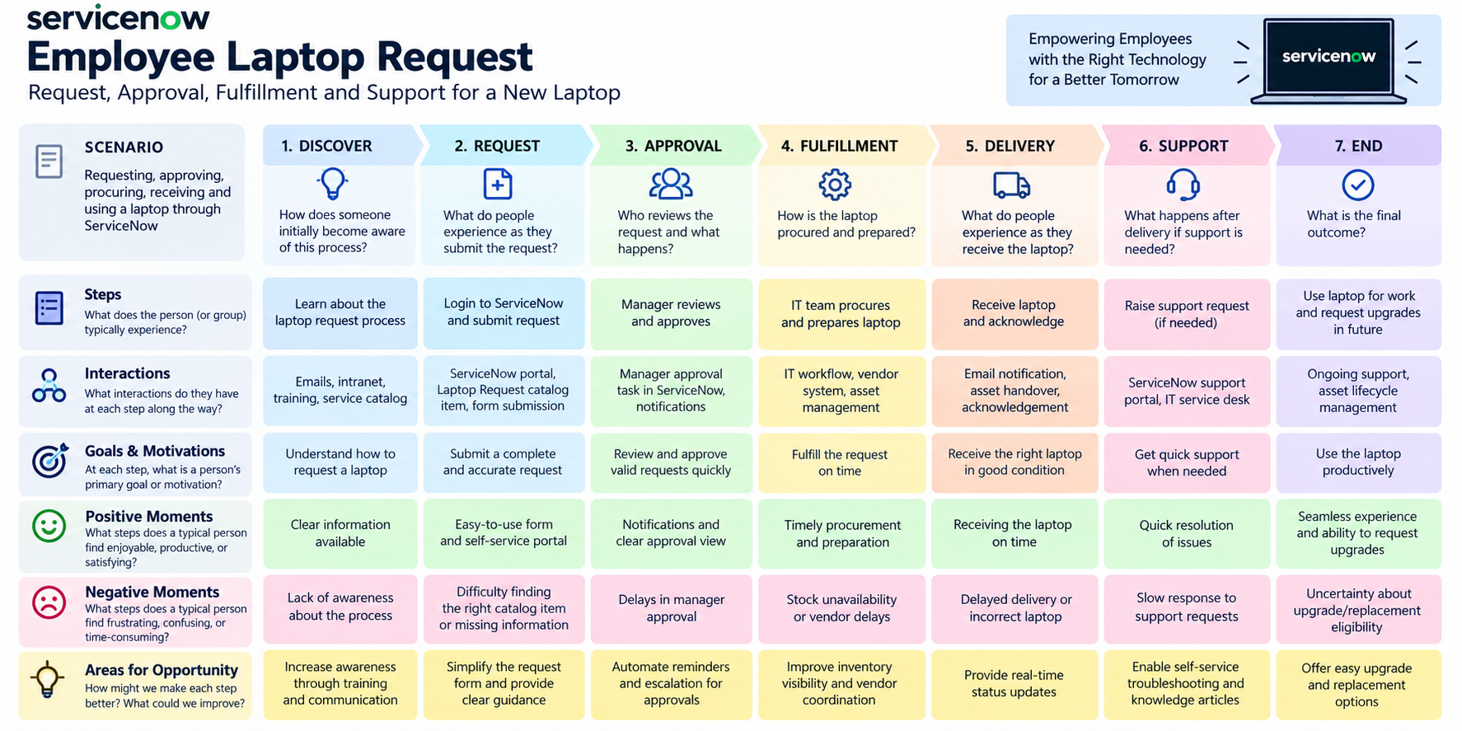
Figure 3.1: Customer Journey Map for the Laptop Request process

3.2 Solution Requirements
FR No. | Functional Requirement (Epic) | Sub Requirement (Story / Sub-Task)
FR-1 | Employee Laptop Request | Submit request / Capture employee details / Select laptop type / Add justification
FR-2 | Manager Approval | Route to manager / Approve or reject / Record decision
FR-3 | IT & Asset Validation | Validate eligibility / Check current asset / Confirm inventory
FR-4 | Fulfillment & Closure | Create IT task / Update progress / Record completion
FR-5 | Notifications & Tracking | Notify stakeholders / Show status / Maintain history
FR-6 | Reporting & Administration | Filter requests / Monitor lifecycle / Track SLA
FR No. | Non-Functional Requirement | Description
NFR-1 | Usability | Guided catalog form, mandatory fields and clear request states.
NFR-2 | Security | Authenticated access, roles and ACLs enforce least privilege.
NFR-3 | Reliability | Approval and fulfillment actions are recorded with controlled state transitions.
NFR-4 | Performance | Efficient queries and automated workflow minimize manual processing and unnecessary client work.
NFR-5 | Availability | Application uses the managed ServiceNow platform and its workflow services.
NFR-6 | Scalability | Additional laptop types, approval rules and fulfillment teams can be added without redesigning the core workflow.

3.3 Data Flow Diagram
Employee → Employee Center → Record Producer → Laptop Request Form. From the stored request, Flow Designer creates manager approval and handles the decision. Business Rule provides duplicate prevention and ACLs control access. Email Notification sends the final outcome to the requester.
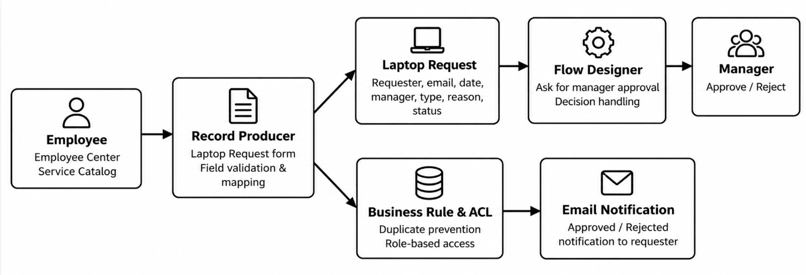
Figure 3.2: Data Flow Diagram of the ServiceNow Laptop Request Application

3.4 Technology Stack
Layer | Technology / Service | Purpose
User Interface | ServiceNow Employee Center | Self-service employee request interface.
Request Interface | Record Producer | Captures and maps request fields.
Application Workflow | Flow Designer | Automates approval, decision handling, status updates and notifications.
Business Logic | Business Rule | Prevents duplicate requests within the same year.
Access Control | Roles, Groups and ACLs | Provides role-based permissions.
Approval | sysapproval_approver | Stores manager approval/rejection records.
Database | ServiceNow Custom Table | Stores Laptop Request Form records.
Notification | ServiceNow Outbound Email | Notifies the requester of the approval outcome.
Platform | ServiceNow | Provides the application platform and administration environment.

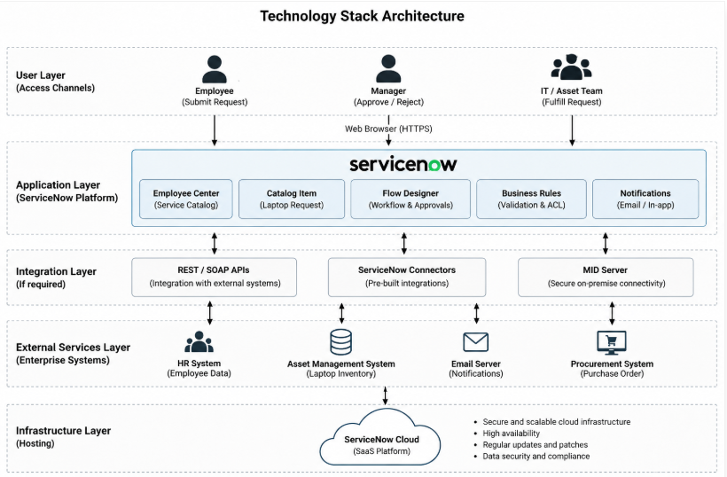
Figure 3.3: Technology Stack Architecture

4. PROJECT DESIGN

4.1 Problem-Solution Fit
The proposed solution directly addresses the identified problems. The employee receives a centralized request form and status visibility. The manager receives an automated approval task. IT receives controlled access and trackable records. Duplicate requests are blocked by the Business Rule.
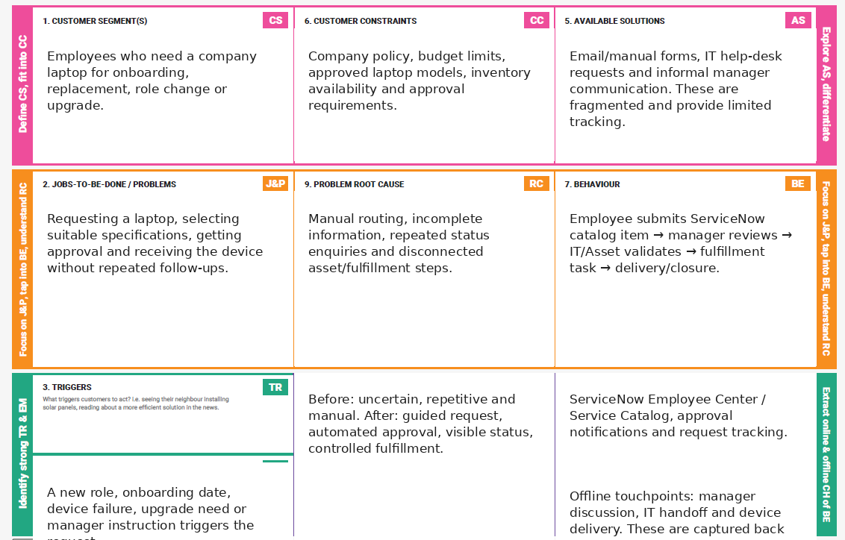
Figure 4.1: Problem-Solution Fit Canvas adapted to the project

4.2 Proposed Solution
Parameter | Project-specific Description
1. Problem Statement | Manual laptop requests through email or verbal communication are difficult to track and can cause delayed approvals, duplicate requests and repeated follow-ups.
2. Idea / Solution description | A ServiceNow application using Employee Center, Record Producer, Flow Designer, Business Rule, ACLs and email notification to centralize and automate laptop requests.
3. Novelty / Uniqueness | Combines self-service requesting, automated manager approval, yearly duplicate prevention, role-based access, status tracking and notifications in one ServiceNow workflow.
4. Social Impact / Customer Satisfaction | Reduces employee frustration and follow-ups while improving transparency, accountability and processing consistency.
5. Business Model (Revenue Model) | Primarily an internal enterprise solution that reduces manual administrative effort and processing cost; the implementation approach can be reused for other organizations.
6. Scalability of the Solution | Can be extended to multiple departments, laptop categories, multi-level approvals, asset/procurement integration, onboarding, replacement requests and dashboards.

4.3 Solution Architecture
The solution architecture consists of the employee interface, ServiceNow application components, workflow and business controls, approval processing, database storage and notifications. The employee submits a request through Employee Center and Record Producer. The custom table stores the request. Flow Designer manages manager approval and status decisions. Business Rules and ACLs enforce controls, while outbound email communicates the outcome.
Figure 4.2: Solution Architecture of the ServiceNow Employee Laptop Request Application

5. PROJECT PLANNING & SCHEDULING

5.1 Project Planning
The project is planned across three sprints. The documentation date is 7 September 2026 and the team ID is SWUID2026190365. The total planned work is 22 story points.
Sprint | Total Story Points | Duration | Sprint Start Date | Sprint End Date (Planned) | Story Points Completed (as on Planned End Date) | Sprint Release Date (Actual)
Sprint-1 | 8 | 6 Days | 9 Sep 2026 | 9 Sep 2026 | 8 | 10 Sep 2026
Sprint-2 | 7 | 6 Days | 9 Sep 2026 | 9 Sep 2026 | 7 | 10 Sep 2026
Sprint-3 | 7 | 6 Days | 9 Sep 2026 | 9 Sep 2026 | 7 | 10 Sep 2026
Total | 22 | 18 Days |  |  | 22

Sprint-1: Laptop request form, required-field validation and duplicate-request prevention.
Sprint-2: Manager approval, approval decision handling, status update and email notification.
Sprint-3: Role-based access, ACL configuration and request tracking.
Planned average velocity = 22 / 3 = 7.33 story points per sprint.

6. FUNCTIONAL AND PERFORMANCE TESTING

6.1 Test Coverage
Testing covers the main functional requirements and performance-related workflow behavior of the ServiceNow-Based Employee Laptop Request Application. The UAT scope includes request form validation, manager approval, approval decision handling, duplicate prevention, workflow execution and notifications.

6.2 Defect Analysis
This report shows the number of resolved or closed defects at each severity level and how they were resolved. No formal defects were recorded for the completed test cases.
Resolution | Severity 1 | Severity 2 | Severity 3 | Severity 4 | Subtotal
By Design | 0 | 0 | 0 | 0 | 0
Duplicate | 0 | 0 | 0 | 0 | 0
External | 0 | 0 | 0 | 0 | 0
Fixed | 0 | 0 | 0 | 0 | 0
Not Reproduced | 0 | 0 | 0 | 0 | 0
Skipped | 0 | 0 | 0 | 0 | 0
Won't Fix | 0 | 0 | 0 | 0 | 0
Totals | 0 | 0 | 0 | 0 | 0

6.3 Test Case Analysis
This report shows the number of test cases that have passed, failed and not been tested.
Section | Total Cases | Not Tested | Fail | Pass
Laptop Request Form | 2 | 0 | 0 | 2
Manager Approval Workflow | 2 | 0 | 0 | 2
Duplicate Request Prevention | 1 | 0 | 0 | 1
Workflow Performance | 1 | 0 | 0 | 1
Email Notification | 1 | 0 | 0 | 1
Total | 7 | 0 | 0 | 7

Test Case Execution
Test Case ID | Scenario | Test Steps | Expected Result | Actual Result | Pass/Fail
FT-01 | Laptop request form validation | Enter valid requester, email, date, manager, type and reason. | Valid request data is accepted. | Valid laptop request was submitted successfully and the request record was created. | Pass
FT-02 | Required field validation | Leave required fields blank and submit. | Submission is prevented and validation is shown. | Submission was prevented when required information was missing. | Pass
FT-03 | Manager approval workflow | Submit a valid laptop request and check approval. | Manager approval record is created. | Manager approval record was created successfully for the submitted request. | Pass
FT-04 | Approval decision handling | Approve and reject requests in separate tests. | Status becomes Approved or Rejected accordingly. | Request status changed to Approved when approved and Rejected when rejected. | Pass
FT-05 | Duplicate request prevention | Submit another request for the same employee in the same year. | Duplicate request is blocked. | Duplicate request was blocked with the validation message. | Pass
PT-01 | Flow execution performance | Measure the request-to-approval workflow execution. | Workflow completes successfully without unnecessary delay. | Flow executed successfully from request creation through approval and status update. | Pass
PT-02 | Notification performance | Trigger approval and rejection outcomes. | Requester notification is generated successfully. | Email notification was generated successfully after the approval/rejection outcome. | Pass

6.4 Performance Testing
Test ID | Parameter | Test Method | Result
PT-01 | Flow execution | Execute request creation through manager approval and status update. | Workflow completed successfully.
PT-02 | Notification generation | Trigger approved/rejected outcome and verify notification generation. | Requester notification was generated successfully.

Overall UAT result: 7 of 7 test cases passed, 0 failed and 0 remained untested.

7. RESULTS

7.1 Output Screenshots
The following screenshots show the implemented ServiceNow application and its key outputs.
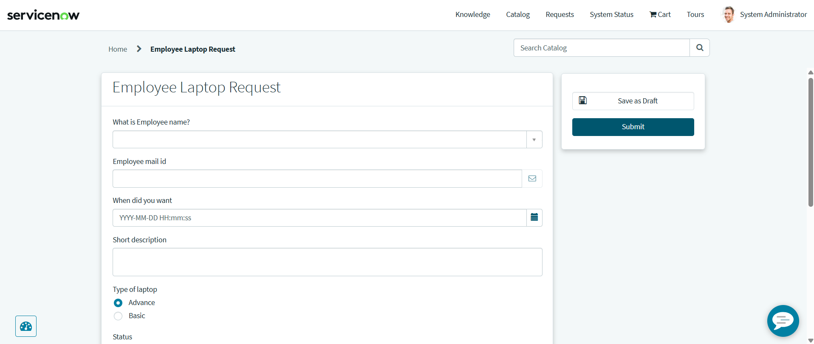

Figure 7.1: Employee Center Laptop Request form.
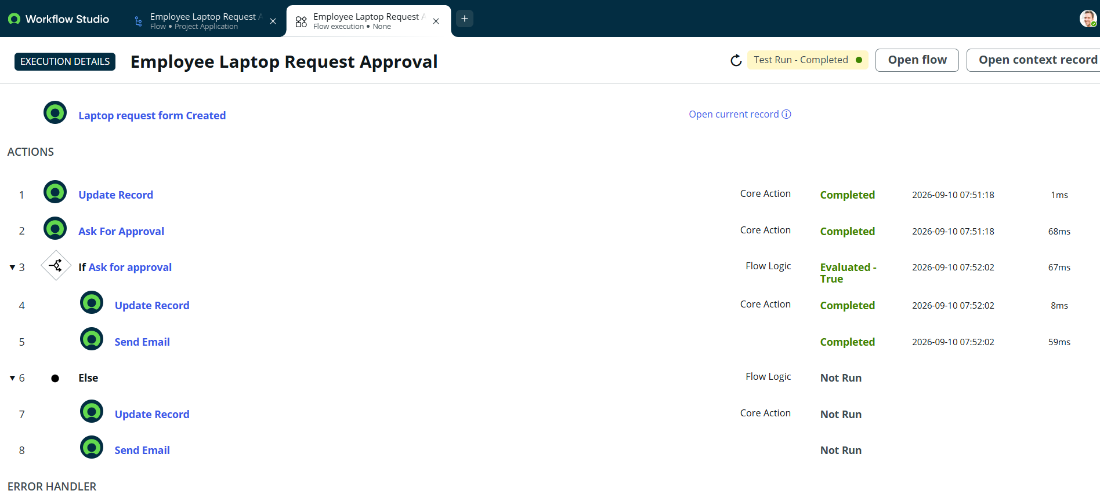

Figure 7.2: Laptop Request Form workflow

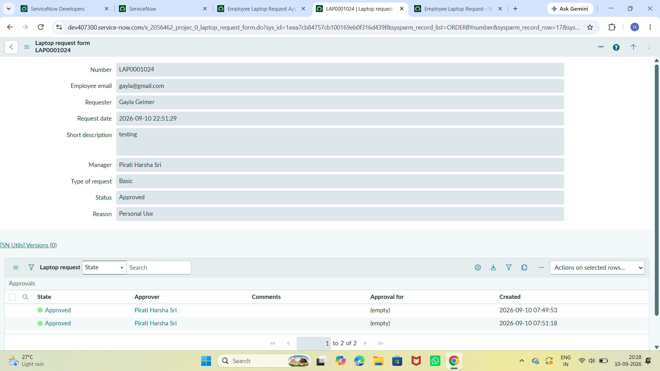
Figure 7.3: Manager approved record.
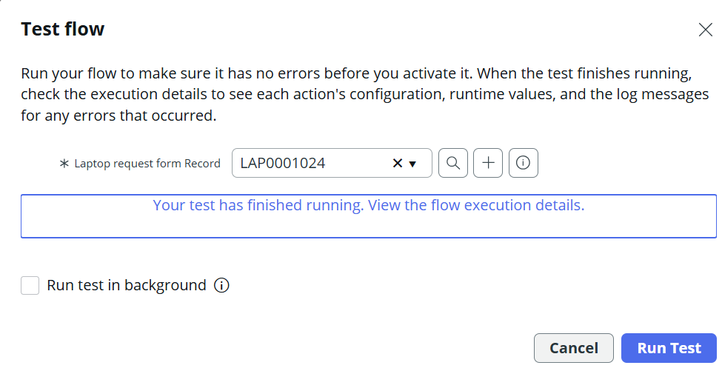
Figure 7.4: Testing the flow
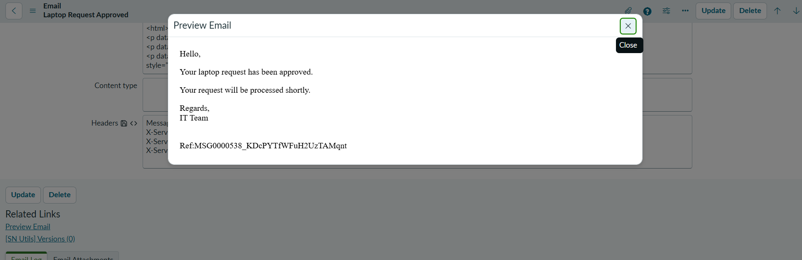
Figure 7.5: Approved Email
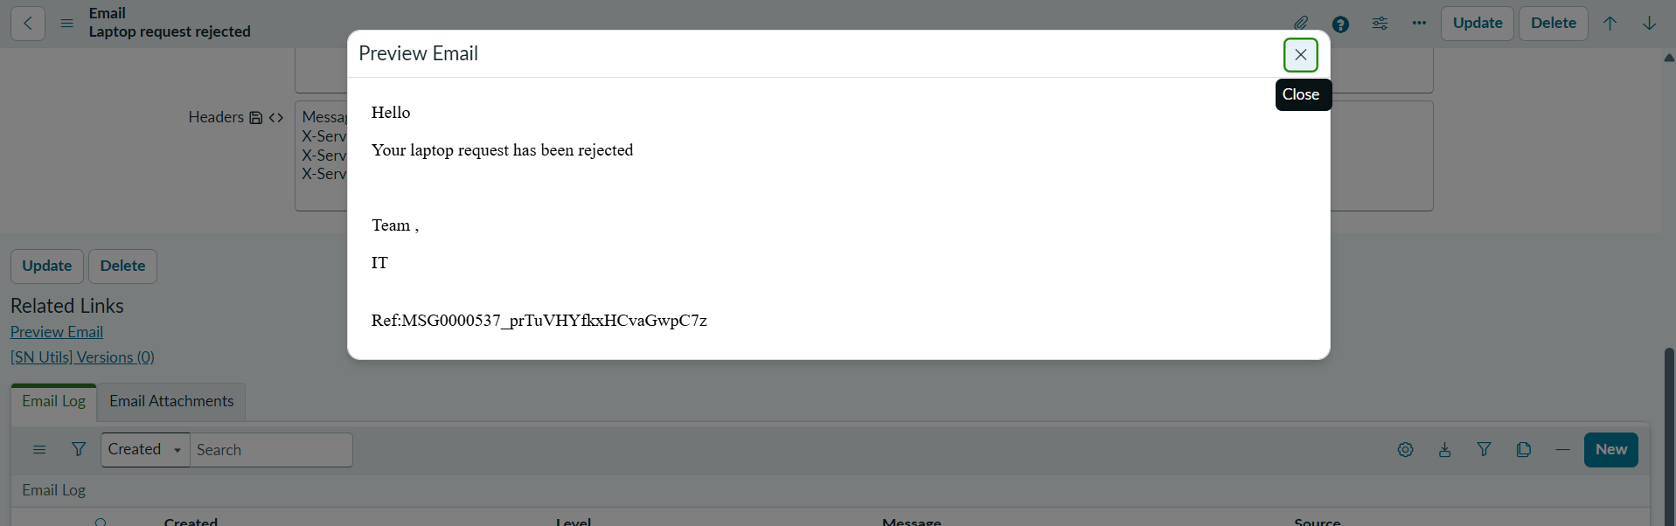
Figure 7.6: Rejected Email
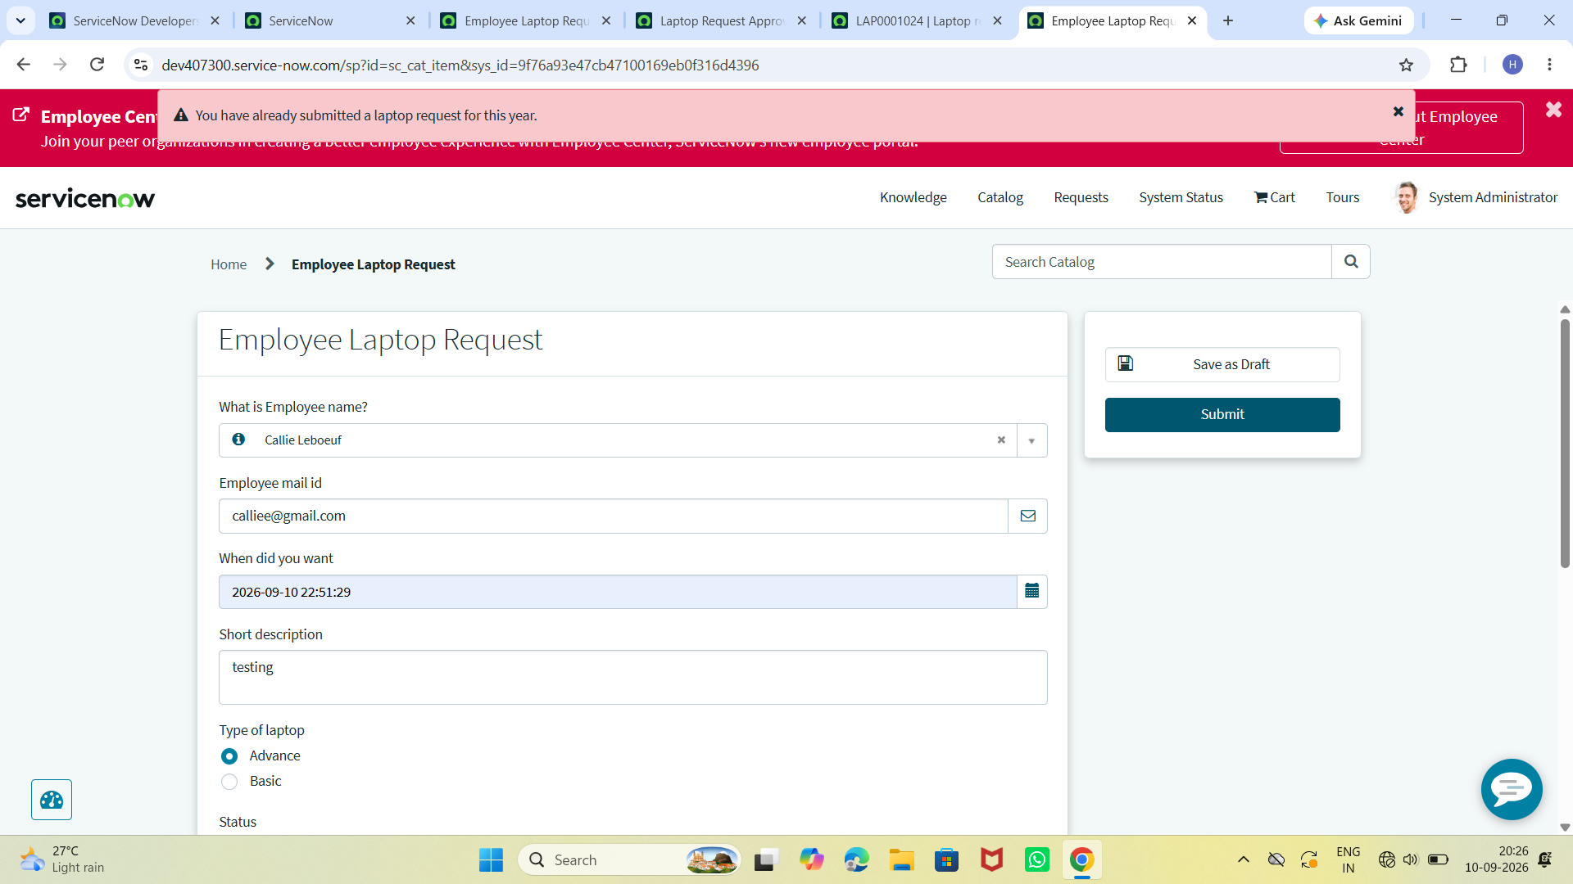
Figure 7.7: Execution of Business Rule

8. ADVANTAGES & DISADVANTAGES

Advantages
- Centralized laptop request process.
- Automated manager approval reduces manual intervention.
- Duplicate-request prevention avoids repeated requests within a year.
- Role-based access improves data control.
- Request status and approval records improve transparency.
- Automatic notifications reduce repeated follow-ups.
- ServiceNow provides a reusable platform for extending the solution.

Disadvantages
- The solution depends on ServiceNow availability and configuration.
- Initial configuration requires ServiceNow administration knowledge.
- The current scope focuses on laptop requests and does not itself perform physical procurement.
- Actual external email delivery depends on the configured outbound-mail environment.

9. CONCLUSION
The ServiceNow-Based Employee Laptop Request Application provides a centralized and automated solution for employee laptop requests. The application replaces manual communication with a structured ServiceNow request process. Employee requests are captured in a custom table, manager approval is automated through Flow Designer, duplicate requests are prevented through a Business Rule, access is controlled through roles and ACLs, and the requester is notified of the final approval decision.
The UAT results show that all seven defined test cases passed, including request validation, manager approval, decision handling, duplicate prevention, workflow execution and notification generation.

10. FUTURE SCOPE
- Integrate with ServiceNow Asset Management for laptop assignment and tracking.
- Integrate with procurement and vendor systems for purchase and delivery tracking.
- Add multi-level approval for specialized or high-value devices.
- Add dashboards and management reports.
- Add laptop replacement, repair and upgrade request types.
- Add SLA monitoring and escalation.
- Extend the solution to desktops, monitors and other IT hardware.
- Integrate with employee onboarding and offboarding processes.

11. APPENDIX

11.1 Project Configuration Summary
Item | Configuration
Application | Project Application
Custom Table | Laptop Request Form
Table Name | x_2056462_projec_0_laptop_request_form
Record Producer | Employee Laptop Request
Requester Field | Requester – reference to sys_user
Employee Email | Email field
Request Date | Date/Time
Manager | Reference to User
Type of Laptop | Basic / Advance
Status | Pending / Approval / Approved / Rejected
Reason | Software Development / Personal Use / Other
Workflow | Flow Designer – manager approval and decision handling
Business Rule | One laptop request per employee per year
Roles | it_manager / it_employee
Groups | IT Managers / IT Employees
ACLs | Manager Read; Employee Read/Create/Write

11.2 Source Code (if any)
The project is primarily implemented using ServiceNow configuration and scripting elements such as a Business Rule. The main project logic is contained within the ServiceNow instance.

11.3 Dataset Link
Not applicable. This application does not use a machine-learning dataset. It stores and processes ServiceNow laptop request records.

11.4 GitHub & Project Demo Link
Demo link
https://drive.google.com/file/d/1Y0-PySeuhOl-qmzpJ9Vxbhz5sI-EKUv_/view?usp=sharing
GitHub Link
https://github.com/harshasripirati/serviceNow-Based-Laptop-Request-Application

11.5 References
https://c4model.com/
https://developer.ibm.com/patterns/online-order-processing-system-during-pandemic/
https://www.ibm.com/cloud/architecture
https://aws.amazon.com/architecture/

